Mayfield High School
English I Honors-----Introduction to Literature & Composition
Supply List & Novels to order
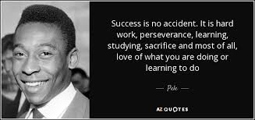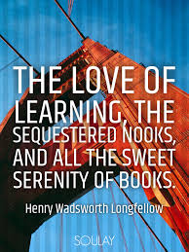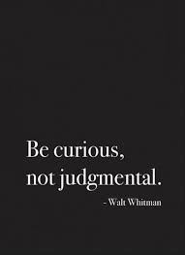

Lucky is the teacher whose students want to know how things work---anonymous

Supplies 8 ½ x 11 composition notebook (notebook just for English)
Binder or folder to organize handouts and notes
One box of Kleenex
loose-leaf notebook paper
pencil & pen & highlighter
Post-It notes
Folder
Text or novel
Text book needs to be covered

Novels you will need to purchase this year:

The man who does not read good books has no advantage over the man who cannot read them---Mark Twain

Please purchase these titles at least two weeks before we start each novel. You will be reminded in your weekly letter and online so you have ample time to find these titles. Please be reminded that MHS students have read these titles before and may be willing to lend their copies to you or to sell it to you inexpensively. Furthermore, now that you know the book titles, scout out Half Price Books and stash them away for the proper quarter. I recommend ordering The Pen Commandments on Amazon since it is not regularly stocked at bookstores and you will also find a better price. If you cannot acquire a book for a personal reason, please see me two weeks before we begin reading the book and I will loan you a copy if I have one.

Summer Boy 21 Matthew Quick (Wildcat Read)

1st The Pen Commandments:
A Guide for the Beginning Writer Steven Frank
Of Mice and Men John Steinbeck
To Kill a Mockingbird Harper Lee

2nd The Catcher in the Rye J.D. Salinger--CS

3rd Macbeth William Shakespeare

4th 1984 George Orwell

